How to: Create a profile with one or two eyes.
The first thing you have to do is go in to the software settings and make sure you select the option to let you calibrate one eye at the time.
You find that setting under Settings > Software… > Tracking tab
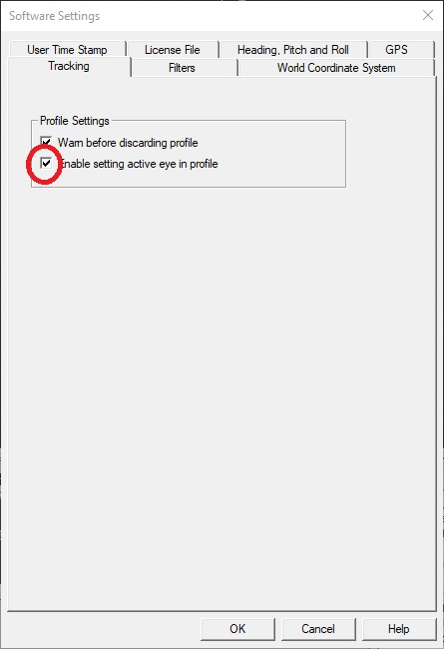
Next thing is to create a new profile.
That is done by going to “Profile” and select “Create New…” (Ctrl+N)
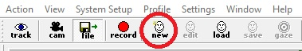
After this you get a prompt to select if you want to use Both, Left or Right eye.
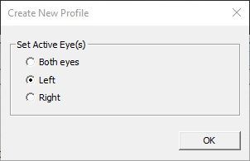
In this example I will select Left.
For the next step you start tracking (as normal), and go ahead and start a gaze calibration.
Profile > Gaze Calibration (Ctrl+G)
Go ahead and train on the points that seem fitting.
For me that looks like this:
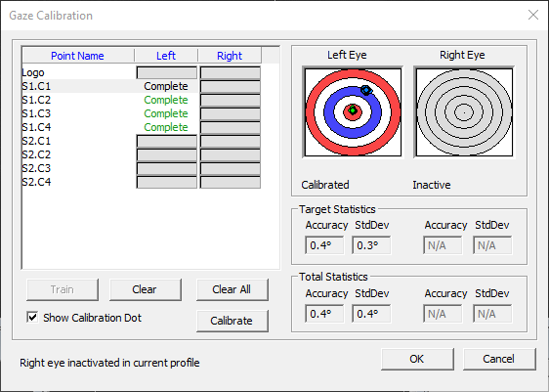

Train the points and press “Calibrate” to get a result and “OK” to start using that newly created gaze calibration.

To be able to use this later it’s wise to save the profile. To dop that you need to stop tracking and the press “Save” or go to Profile > Save As.
Name it something that will help you remember who’s profile it is and what it contains.
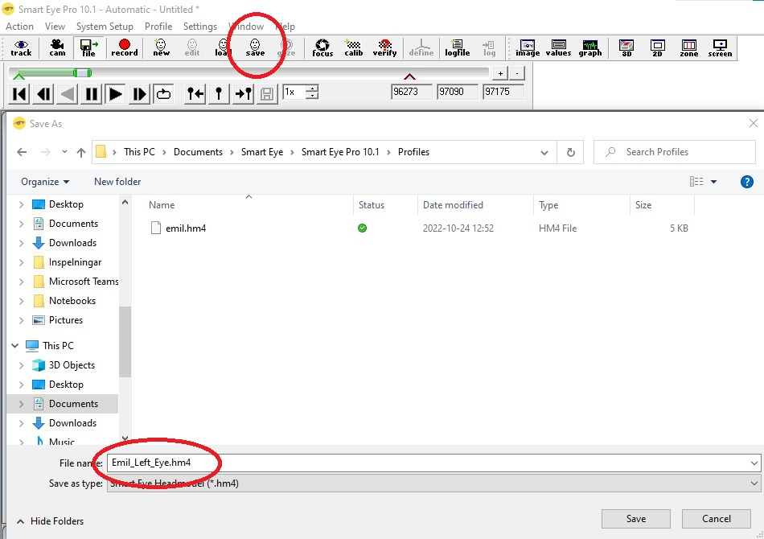

I hope that gives a clear understanding how to create a profile with gaze calibration with the feature to select one or Both eyes.

